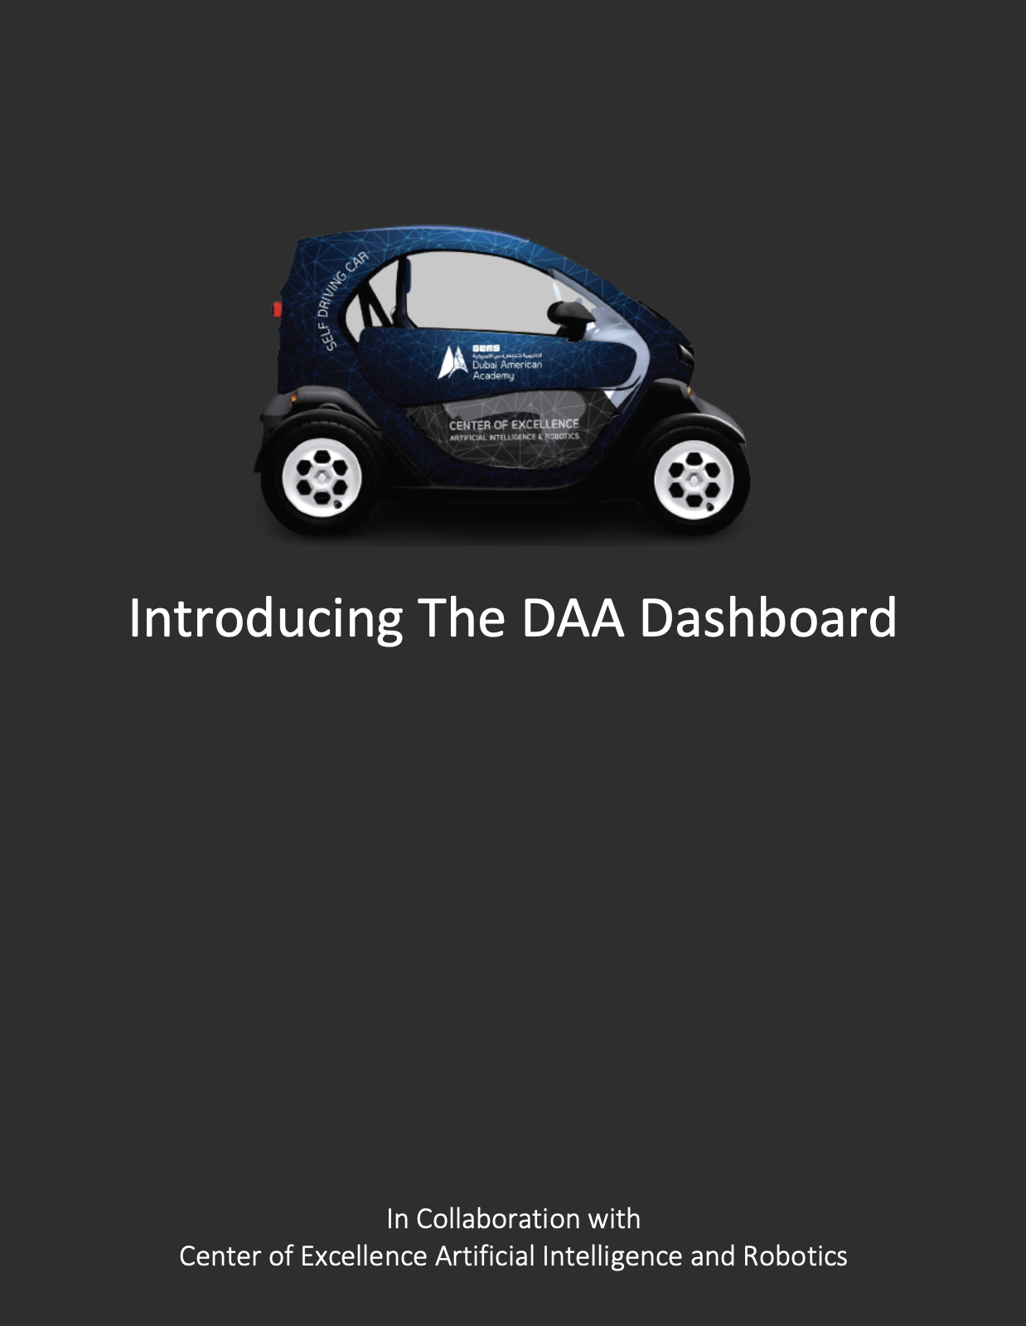



* The Project
* Acknowledgement
* Meet the Team
* Dashboard Layout
* User Flow Diagram
* Facial Recognition
* APIs Used
* Future Prospects

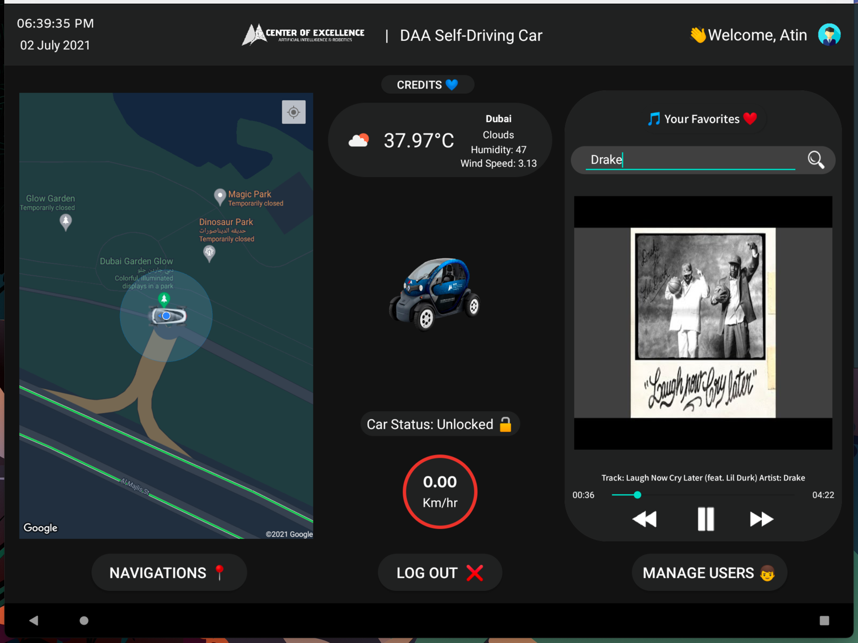

This entire project was built using Android Studio for the Frontend and Python for the Backend. And is open source, available at https://github.com/crypto-code/Car-Dashboard-Studio.







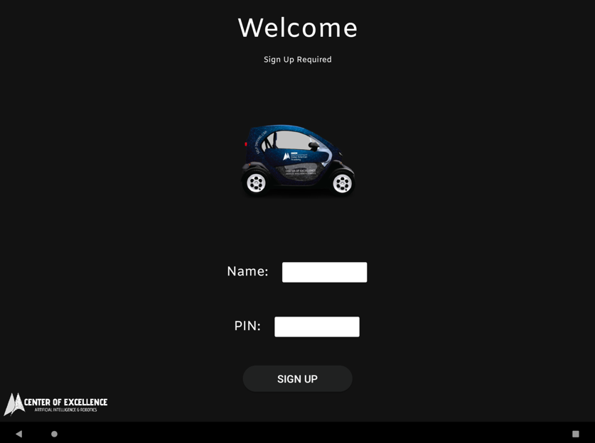 Welcome Screen

Sign Up Screen Register Face Screen

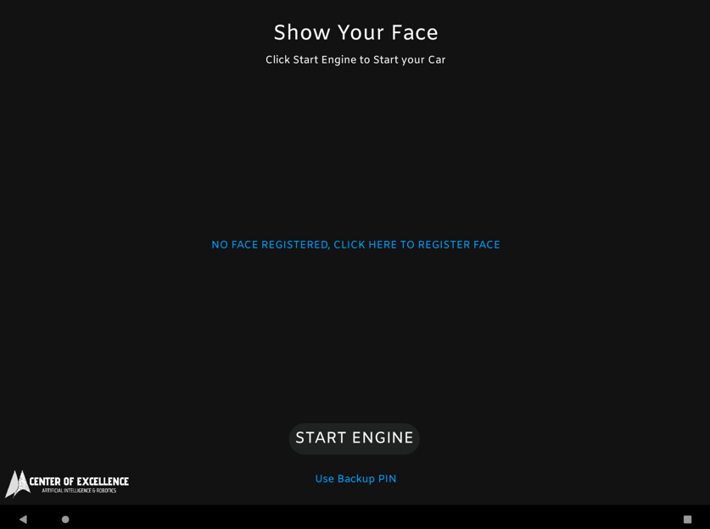

Login Screen Login Screen

(With Face Registered) (Without Face Registered)

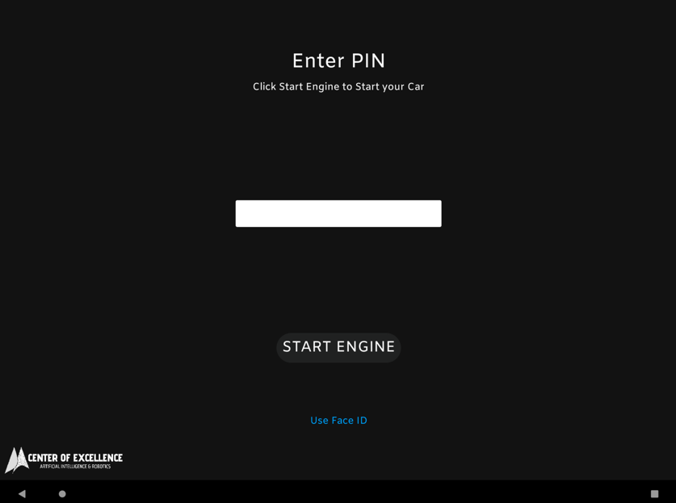

Login Screen

(Using Pin)

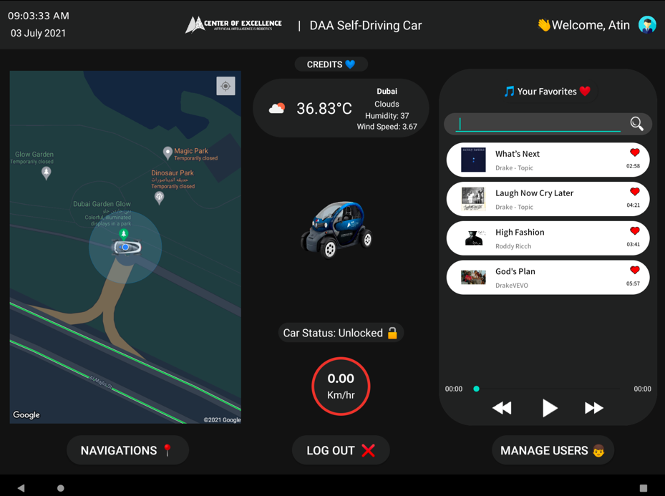



Main Screen (For Admin)

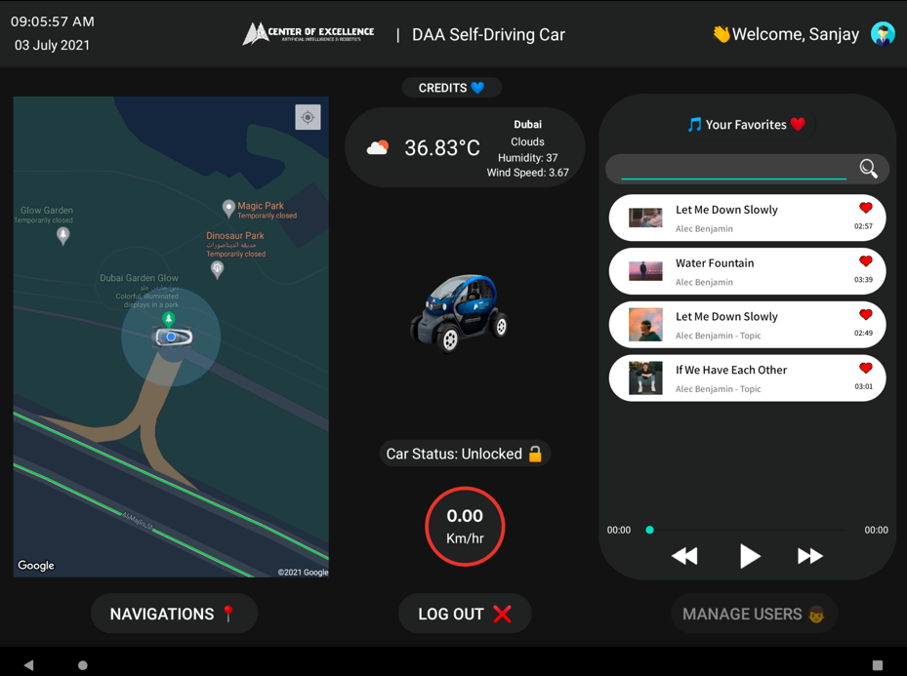

Main Screen (For Non-Admin)



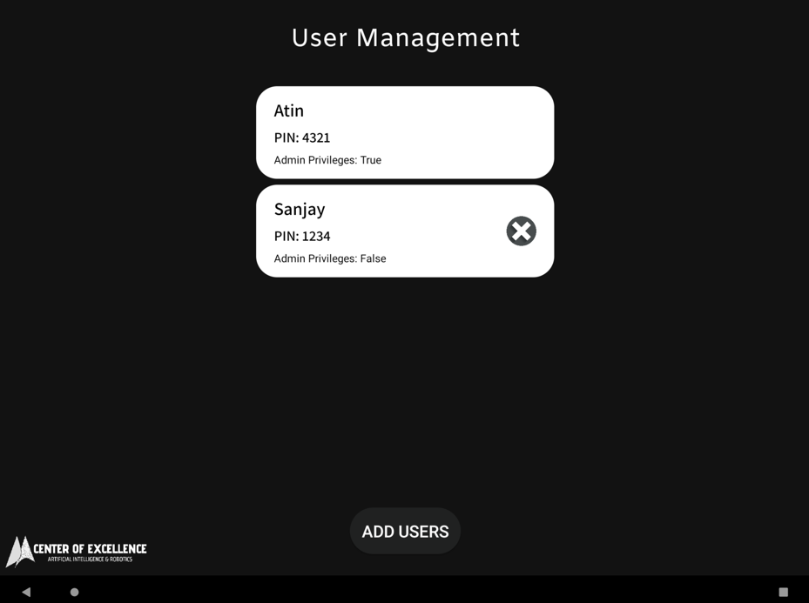

User Management Screen

Add User Screen

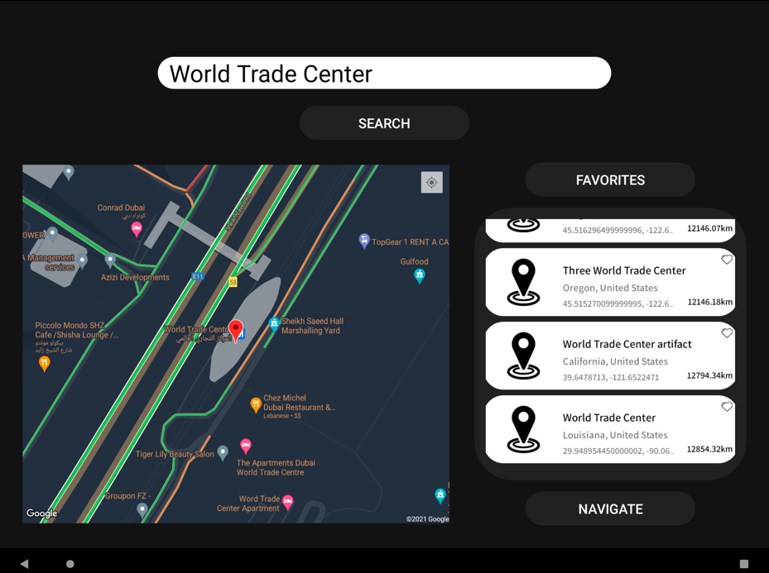

Navigation Screen

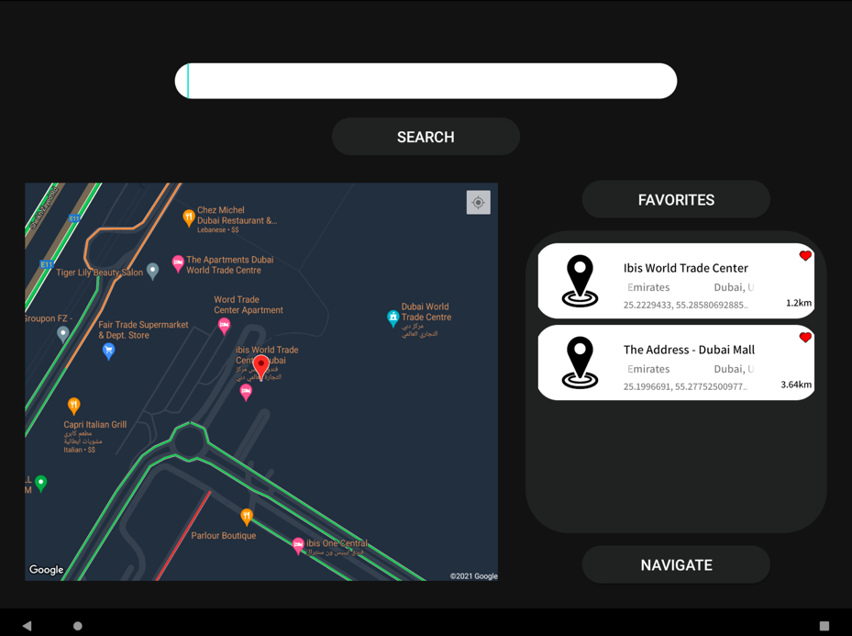

Navigation Screen (Favorites)



The Facial Recognition used in this app runs entirely using the ***face_recognition*** library in Python. The model used for facial recognition has a *99.38%* accuracy on the Labelled Faces in the Wild dataset. Python is linked to Android Studio using the open source ***Chaquopy plugin***. All facial recognition data is stored on a Firebase database.

During the facial recognition stage, the front camera of the Android device is used to capture the image. Then the image is passed as a raw byte stream to the Python backend to extract the facial features. This is then compared against the feature encoding stored in the Firebase database to validate the face.

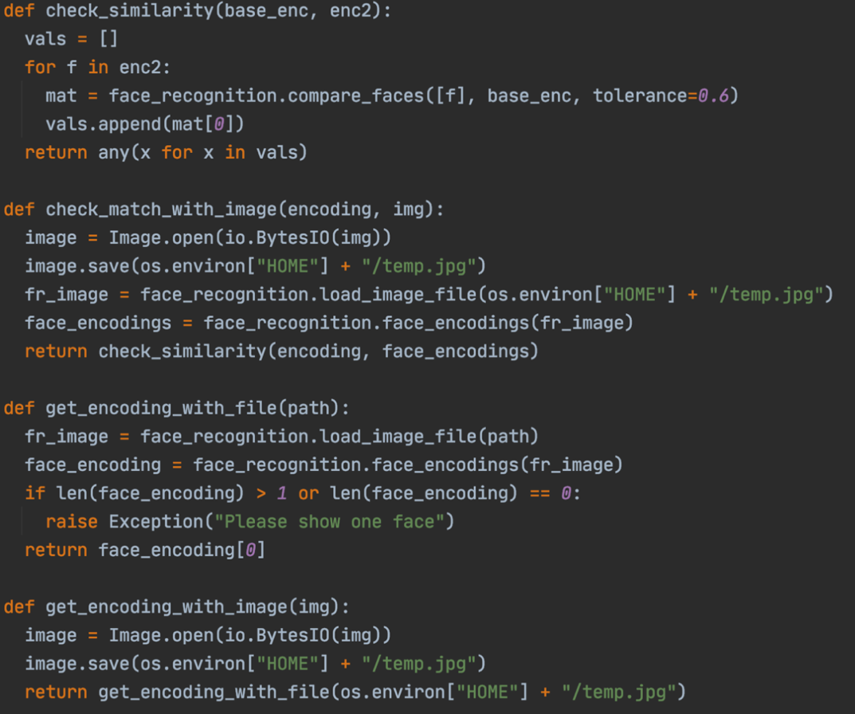

These are the main functions used to process faces in images.

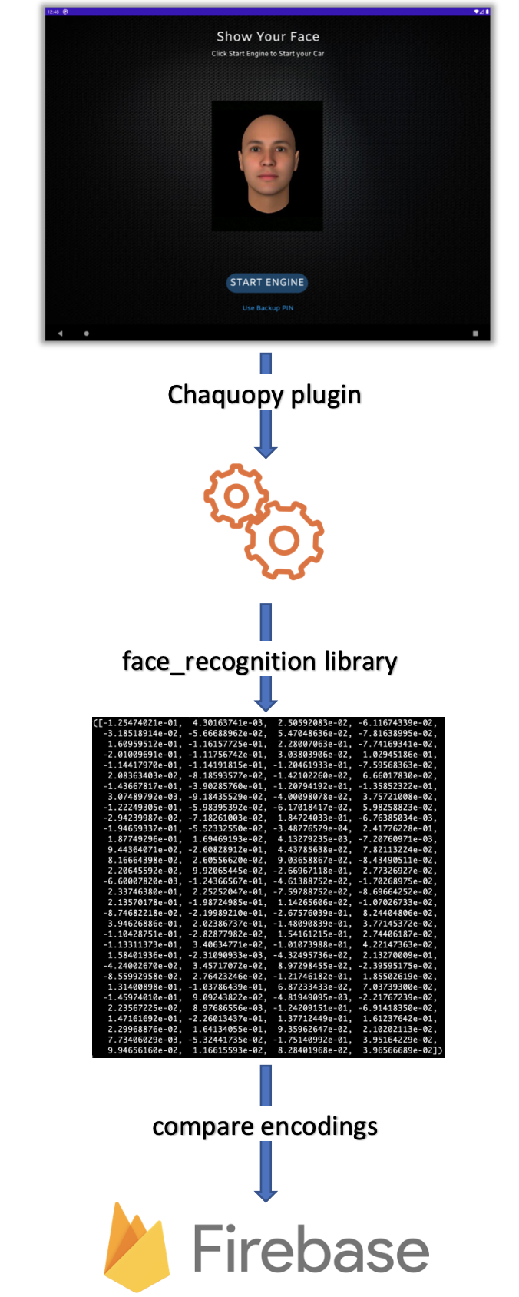



* 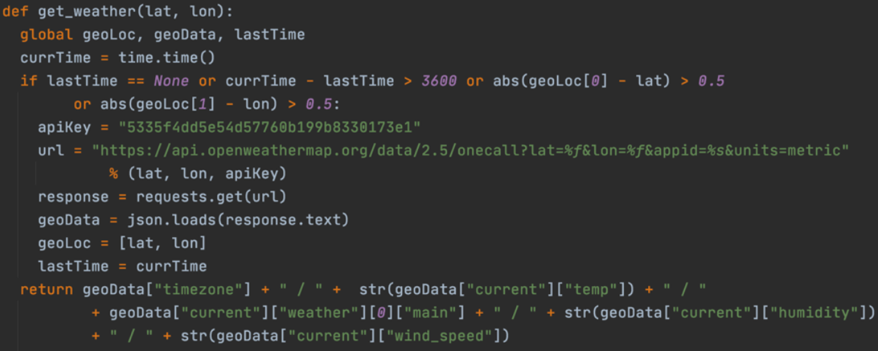**Open Weather Map API:** This is used to get weather updates on the Dashboard. It calls for update every hour and also if the distance travelled exceeds 50km.
* **Google Maps API:** This is used to display the map on the Dashboard. It is also used to calculate the speed of the vehicle.
* 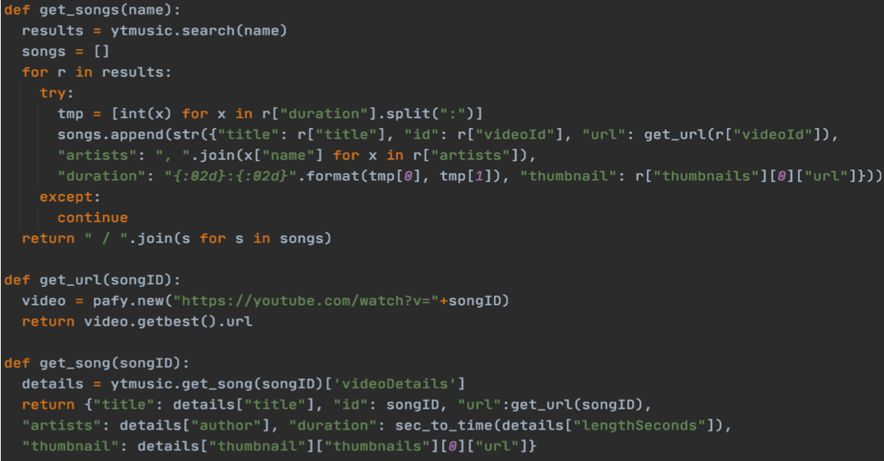**YouTube Music API:** This is used to make the Music Player on the Dashboard. It uses the ***ytmusicapi*** and ***pafy*** library in Python.
* **Photon OpenStreetMaps API**: This is used to get the search results for places in navigation.



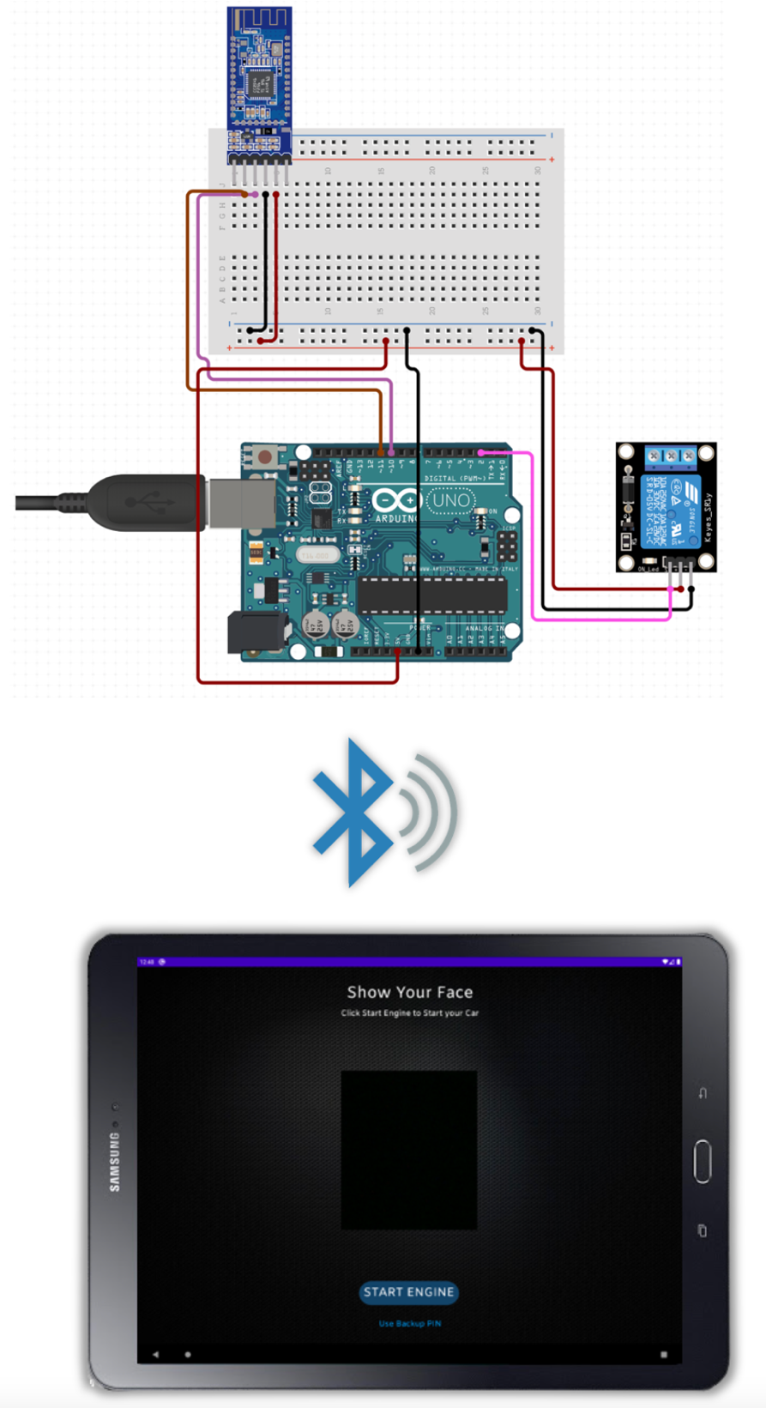The app could be connected to an Arduino on the vehicle and when logged in, the app sends a message to the Arduino via Bluetooth to switch on the relay and start the engine.

